|  |
| --- |
| Indexing Society of Canada |
| Indexers.ca |
| Website Documentation |

|  |
| --- |
| JoAnne Burek  joanne@wordbeats.com  8-23-2017 |

f

Table of Contents

1 Users of the website 1

1.1 Administrators 1

1.2 Contributors 2

1.3 Editors 2

1.4 Subscribers (Members) 2

1.5 Public 2

2 Posts and Events 2

2.1 Tips for writing a post or event (Contributors and Editors) 3

3 Membership Administration 4

3.1 Processing manual payments 4

3.2 Manual membership changes 5

3.3 Expired and cancelled memberships 5

3.4 Download Members and Payments 5

3.5 Membership types and prices 5

4 Listings Administration 5

5 Web Administration 6

5.1 User Administration 6

5.2 Upload PDFs 7

5.3 Contact Us 7

5.4 Update Membership prices and plans 7

5.5 Website Layout 7

6 Website Functions and Feature Details 10

6.1 French support and translation 10

6.2 Membership Functionality 10

6.2.1 New member signs up 10

6.2.2 Member updates information, upgrades membership, or renews 10

6.2.3 How RCP handles a change in membership type or a renewal: 11

6.2.4 RCP Settings 11

6.3 Listing Functionality 11

6.3.1 Member Listings 12

6.3.2 Searches 12

6.3.3 Administration 12

6.3.4 Settings 12

6.4 Events Calendar 13

6.4.1 Settings 13

6.5 Member Directory 13

6.5.1 Settings 13

6.6 Contact Us form 13

7 Themes, Plugins, and Website Customizations 14

7.1 Theme 14

7.2 GP Premium 14

7.3 WP-Globus 14

7.4 Restrict Content Pro 14

7.5 Dynamic User Directory 15

7.6 Advanced Classifieds & Directory Pro 15

7.7 The Events Calendar 15

7.8 Ninja Forms 16

7.9 Display-posts-shortcode 16

7.10 Lightweight Grid Columns 16

7.11 Lightweight Social Icons 16

# Users of the website

**How to Log in**

**Administrators, Contributors, Editors: log in at indexers.ca/wp-admin**

**Members: log in through “Member Login” in the website header.**

## Administrators

Web Administrator can

* Upgrade WordPress
* Update all plugins as required, except for GP Premium, Restrict Content Pro, and Advanced Classifieds and Directory Pro, which are updated by the Developer
* Create user accounts for administrators, editors, and contributors
* Change users’ access roles
* Reset passwords (if requested—members can reset their own passwords)
* Hide specific user accounts from Membership Directory
* Switch the layout of the Membership Directory
* Download form submissions (e.g., Contact form)
* Create/edit/delete forms
* Create/edit/delete post categories, and event categories
* Edit navigation bar, sidebar, footer

Membership Administrator can

* Activate new members after payment has been received manually
* Delete listings of expired or downgraded (basic) members
* Cancel members
* Delete expired and cancelled members (they appear in Membership Directory until deleted)
* Export membership list into Excel file

Either Web or Membership Administrator can

* Create and edit membership types and prices
* Edit email messaging for membership registration and renewals (welcome, renewals, invoice, etc.)

Developer can

* Change Listings categories and checkboxes
* Update the following plugins: GP Premium, Restrict Content Pro, and Advanced Classifieds and Directory Pro (because of customizations)
* Update the theme
* Change page design, listed profile form design, membership form design
* Change number of posts displayed on home page
* Troubleshoot problems

Note: Developer also needs access to webnames.ca account.

## Contributors

Create a new post

Create a new event

Edit own post or event

Submit content for Editor to review and publish

## Editors

Create or edit content (posts, events and pages)

Publish pending posts, events, and pages submitted by Contributors

Upload media (files and photos) and add to content

Create new categories of posts and events

## Subscribers (Members)

Note: Unlike the user roles above, logged-in Members cannot see the WordPress Dashboard

All members (through the Restrict Content Pro plugin)

Create membership through Registration page

Reset password

Renew/upgrade/downgrade membership

Listed members, through the Classified Ads plugin

Create, edit, delete their own listings

Upload an image to their own listings

## Public

Search on Find an Indexer Search page

Use Contact forms

# Posts and Events

**Where the posts appear**

Home page: the five latest posts, plus any sticky posts.

Blog page, which we are calling News and Articles. This page is accessed from the “Read All Posts” link on the home page (http://indexers.ca/resources/news-and-articles/)

Posts in certain categories also appear as follows:

Indexing articles: <http://indexers.ca/category/indexing/>

Awards: <http://indexers.ca/isc-awards/>

Conferences: <http://indexers.ca/annual-conference-2/>

**Where events appear**

The next five events appear in the sidebar under Upcoming events.

All events appear on the Events page.

## Tips for writing a post or event (Contributors and Editors)

To write a post or event, you need to access the WordPress panel. Log in with your membership and go to <http://indexers.ca/wp-admin/>

On the top bar, click **+ NEW** and select Post, Page, or Event.

On the right sidebar, select the appropriate category (conference, announcement, award, etc.)

**Restricting content to members only**

If the post or event is for members only, scroll down to “Restrict this Content” and “Member access options.” Select “Members with an access level”:

* For basic and listed members, select “1 and higher”
* For listed members only, select “2 and higher”.

To restrict only a portion of the content to members only, leave the Member access options at “Everyone” and surround the restricted content with tags:

[restrict level=1]…[/restrict]

or [restrict level=2]…[/restrict]

**Bilingual content**

Posts and events have an English tab and a French tab for the title and body content. Use these tabs to write the English and French content. If you put nothing into the French tab, and the page is viewed with the language selector set to French, the page display will default to the English content.

If the post is going to be French only, copy the content also to the English tab. Otherwise, when the post is viewed in English, the post title will appear and there will be no content.

**To make a post sticky (for Editors)**

To force the post to stay at the top of all other posts on the home page, even after newer posts are published, make it a sticky post. On the right sidebar, next to Visibility, click Edit and select “Stick this post to the front page.”

**Images (for Editors)**

To keep the page loading efficient and fast, resize images to be around 500 KB or less—certainly under 1MB.

# Membership Administration

As Membership Administrator, you will receive email notifications when

1. a new member is activated or an existing member is renewed or upgraded/downgraded
2. a membership expires or is cancelled (applies to members who have auto renewal)
3. a listing is created or deleted in the Register of Indexers Available (Optional for Membership?)

Email (1) is for information. The email makes no distinction between new members and renewed/upgraded members. In a future version, the date joined and the address will be included in the email so that you can tell from the email if it’s a new member.

Email (2) requires your action. See “Expired and Cancelled Memberships” below.

Email (3) is for information only and should require no action. Management of listings is covered in another section.

## Processing manual payments

Memberships are activated automatically when a new member subscribes with payment type “PayPal.” However, if the payment type is “Manual,” then the membership is not activated until the payment is processed.

Once the cheque or Interac payment is received and cleared, you can process the manual payment:

1. Log in at http://indexers.ca/wp-admin
2. Go to the WordPress Dashboard, under the Restrict menu, go to Payments.
3. Click the “Pending” tab to find the pending payments.
4. Hover over the User and click Edit.
5. Change Status to “Complete” and click Update Payment

If there is no pending payment for the user, then you will have to create a payment. This happens when an existing member chooses to not use the online registration form.[1]

In this (hopefully rare) instance, there will be no pending payment on the website and you will have to create the payment.

To create a payment for an existing user:

1. Go to the WordPress Dashboard, under the Restrict menu, go to Payments.
2. Click “Create a Payment”.
3. Start typing the user’s Name (it’s on the printed form) and select the one that matches in the dropdown list.
4. Enter the amount and date.
5. Enter a unique transaction id (or leave blank)
6. Change Status to “Complete” and click Update Payment

## Manual membership changes

Once a member has joined, they have complete control over their membership. Except for processing manual payments, no intervention should be required.

However, you can make changes to memberships from the Restrict/Members screen. You can manually change a membership status to Expired, Cancelled, Pending, Active, or Free, and you can change an expiry date.

“Free” status might be used to make someone an honorary member.

## Expired and cancelled memberships

When a membership expires or is cancelled, the member must also be deleted as a User. This is in order to remove the member from the Membership Directory.

1. Go to the WordPress Dashboard, under the Users menu, go to All Users.
2. Scan the list or use the Search Users bar on the user’s Name. The member’s Status should be “expired” or “cancelled”.
3. Hover on the Username and click Delete.
4. If the member had any listings or posts, then an option to delete or attribute content will appear. Since you don’t want to delete any posts the member may have written, attribute content to “Contributors”, and confirm delete. Then go into Listings (see Listings Administration) and delete any listings with the Author “Contributors”.

## Download Members and Payments

Go to the Restrict/Export screen to download memberships and payments to a CSV file.

## Membership types and prices

Go to the Restrict/Settings/Subscription Levels screen to add or edit membership types and edit membership prices.

# Listings Administration

Listings are found in the WordPress Dashboard under the Classifieds & Directory menu, All Listings.

Listings are set to expire after 365 days. The member automatically receives an email notification to renew 30 days before it expires. On the expiry date, if the listing is not renewed, another email is sent inviting the member to renew. Unless the listing is renewed, it is automatically deleted 15 days after expiry.

As long as the member maintains a Listed membership, he or she will be able to keep the listing renewed.

If the member downgrades membership type from Listed to Basic, he or she will no longer have access to renew the listing and it will eventually expire and be deleted (moved to Trash).

As an Administrator, you can

* Change a listing’s expiry date: click on the listing and set the date in the right sidebar
* Delete a listing immediately: hover on the Title and click Delete
* Recover a listing from Trash: click Trash, hover over the listing, and click Restore

When a membership has been deleted (see Membership Administration), the member’s listings will be reassigned to the Author “Contributors”. Delete any of these posts that you find in the listings.

Work-around for potential fraud

It is possible for a member to sign up as Listed, create a listing, and then quickly renew as Basic, getting a substantial credit for the extension. A future enhancement will make these easier to detect.

For now, you can detect these by noticing an unusually small payment amount on the email notification (Email (1) above).

**Listing Categories and Checkboxes**

These are controlled by the Categories and Custom Fields screens under the Classifieds & Directory menu. The impacts to existing listings from making changes to custom fields have not yet been tested. Therefore, for now, any changes should be made by the Developer.

# Web Administration

## User Administration

Members are added automatically when they sign up through the membership registration. They are given the user role “Subscriber.”

Memberships that are expired or cancelled must be deleted, or else these memberships will show up in the Membership Directory and their listings will linger on until they expire. This is handled by Membership Administration.

A special account with the username “Contributors” has been set up to own the content created by members who leave. When the membership of a contributor or editor expires, the content created by them is attributed (reassigned) to “Contributor”. This is handled by Membership Administration.

## Upload PDFs

Where to link the uploaded PDFs

**ISC/SCI Bulletin**

* Latest Bulletin on http://indexers.ca/members-area
* All other Bulletins on Resources/Bulletin

**Chat transcripts:**

* http://indexers.ca//members-area/on-line-chats/chat-transcripts/

**Conference downloads**

* http://indexers.ca/resources/conference-downloads/

**Newsletters of Indexing Societies:**

* http://indexers.ca/resources/newsletters-of-indexing-societies/

Each society has a section - open the appropriate section (click the pencil icon) and upload in the section.

**Society Administration**

* http://indexers.ca/members-area/society-administration/

Each category has a section - open the appropriate section (click the pencil icon) and upload in the section.

## Contact Us

The Contact Us form was created using the plugin Ninja Forms. There are separate forms for English and French.

When a form is submitted, an email with the form content is sent to the Web Administrator for forwarding on to the appropriate party.

A CSV file of form submissions can be downloaded from the WordPress Dashboard screen Ninja Forms/Submissions.

## Update Membership prices and plans

Membership prices and plans are on the WordPress Dashboard screen Restrict/Subscription Levels.

## Website Layout

See Figures 1 and 2.

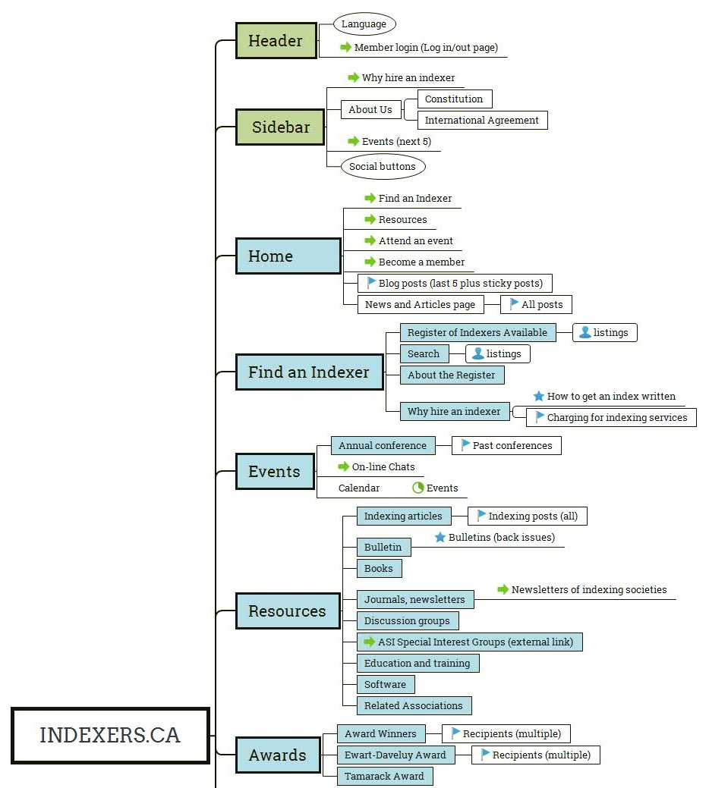

Website Layout (part 1)

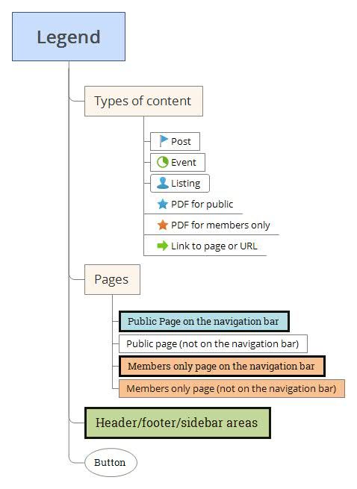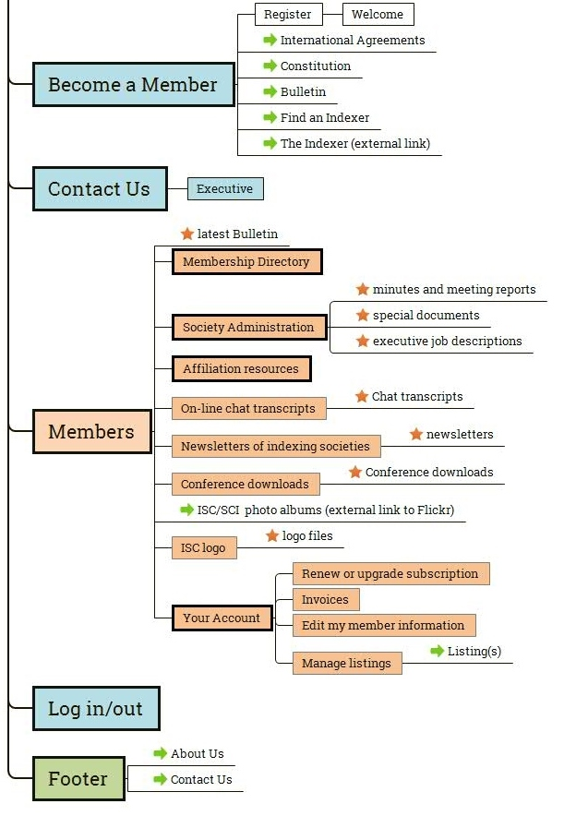

Website Layout (part 2)

Legend

# Website Functions and Feature Details

## French support and translation

Multilingual support is provided by the WP-Globus plug-in. The website header contains a language selector to switch between French and English translation.

## Membership Functionality

Membership is handled by the Restrict Content Pro (RCP) plug-in. An ISC/SCI membership equates to a “subscription” in RCP.

The subscription types, prices, and access levels are defined in the Restrict/Subscription Levels panels in the WordPress Administration Screens.

Access Levels are used to control access to content. The higher the Access Level, the more restricted the content. Basic memberships are Access Level 1. Listing memberships are Access Level 2.

Access Levels are assigned to each page and post. The default is Access Level=0 (public). Pages with Access Level=1 is for all members (1 and 2). Pages with Access Level=2 is for Listed members only.

Content inside a page or post can be hidden from members or displayed only to members by inserting it between the [restrict level=] shortcodes. For example, [restrict level=1]…[/restrict] displays the content only to members (Access Level=1 and higher).

### New member signs up

A visitor signs up to be a member at the Register page (http://indexers.ca/become-a-member/register/).

After filling in details and selecting a subscription (membership type) the visitor completes the registration with the checkout process. Current payment methods are PayPal (PayPal account or a credit card) and Manual (cheque or Interac).

After payment through PayPal, the visitor is sent to the Welcome page. The member status is activated automatically.

On submitting with the Manual option, the visitor is sent immediately to the Welcome page. The member must wait for Membership Administrator to activate the membership.

Upon manual activation, the new member receives an automatically generated email from the Membership Administrator. The text for the email (and all automatically generated emails from this plug-in) can be edited in the WordPress Dashboard Screen Restrict/Settings/Email.

### Member updates information, upgrades membership, or renews

Once the membership has been activated, the member can

Change password

Update personal information

Upgrade, downgrade, or renew the membership

View payment history and print the payment invoice

Edit the Listing profile, if the membership type is Listed

This is done at the Your Account page.

Three weeks before the expiry date, the member receives an automatically generated email reminder.

If the member does not renew by the expiry date, another email is automatically generated to invite the user to rejoin.

### How RCP handles a change in membership type or a renewal:

All membership pricing is based on a one-year term. In the event of an upgrade or downgrade in the middle of the term, RCP calculates the credit for months past, and applies it to the invoice for the new term, which amounts to a new full 12-month term. Upon submission, RCP resets the member’s expiry date to 12 months away. It also adds a note to the “User Note” of the member’s record.

### RCP Settings

Members cannot cancel their membership and get a credit.

Members cannot delete their own User record.

Members log in with their email ids, instead of allowing them to choose a username. Note to Developer: This is controlled by coding in the child theme.

Only PayPal and Manual payment methods are set. There are many other payment services offered.

All emails automatically sent to members come from the Membership Administrator username.

## Listing Functionality

Find an Indexer searches and the member listings are managed by the Advanced Classifieds and Directory (ACADS) plug-in.

A listing is created in a category of either English or French.

A listing consists of

* checkbox entries for each of the major subject areas, materials, and skills
* text field for the member’s profile description
* title field, which could be the indexer’s personal name or business name (the listing owner’s name will be displayed automatically in listing searches).
* contact details
* an image

All fields are optional except title (indexer’s name or business name).

The language selected determines whether French or English subject areas, materials, and skills appear in the listing and search form.

All fields in the form are managed in the WordPress Dashboard Screen: Classifieds & Directory/Custom Fields.

### Member Listings

Only logged-in members with subscription with Access Level 2 (i.e. Listed subscription types), can create and edit their own listings. Access is through the Your Account page, where the link “Edit my listing” is visible only if the member has Access Level 2.

The link leads to the Manage Listings page, where the member can create a new listing or edit an existing one. The plan is to allow one English and one French listing per member.

A listing is published automatically when it is created.

### Searches

The Find an Indexer page displays all listings, as it does in the old website. It also allows the reader to display just the English or just the French listings.

The Search form allows searching by keyword and by checking the boxes of the subject/materials/skills fields.

When the reader selects a listing, the complete list of subject/materials/skills appears, along with a small contact form which the reader can use to contact the listing owner directly.

### Administration

The Membership Administrator receives an email when

* a new listing is created
* when a listing expires

Currently there is no limit on the number of listings a member can have.

There is no automatic cancellation of listings if the member leaves. The Membership Administrator can go to the WordPress Dashboard Screen: Classifieds & Directory/All Listings to delete listings belonging to expired or downgraded members.

### Settings

Form:

* Description length limit is 1000 characters.
* Each of the subject, material and skill checkbox items should end in a comma (except the last one) so that they display separated by commas in the listing display.
* Maximum one image per listing.

Listing display:

* Listings are ordered by title. Random order may be possible in a future development.
* Listings expire after 365 days. The member will receive an automatic email with a link to renew the listing.

## Events Calendar

The Events page is provided by the plugin “The Events Calendar” from Modern Tribe. It is a template, not a page (you won’t find an Events page in the list of pages on the Dashboard).

The content above the calendar is custom content. To make a change, the Developer has to modify the template in the child theme.

The Events widget (in the sidebar) displays the next 3 events.

### Settings

Event calendars could be displayed by event category, but we have not implemented this.

All events are retained forever, that is, until we delete them.

The number of events in the Events widget can be changed in the settings.

## Member Directory

Member directory is provided by the Dynamic User Directory plug-in.

### Settings

The settings are on the WordPress Dashboard screen Settings/Dynamic User Directory screen.

All usernames are included in the directory except those with Administrator access and the username “Contributors” (user account that owns any posts created by former members). Other names that can be excluded are configured on this screen.

The directory display can be switched to Alphabet Letter Links (like a Rolodex). Currently it is single page display.

## Contact Us form

This form was created using the plugin Ninja Forms. For bilingual forms, it is best to create separate forms for English and French.

New forms can be created and embedded on any page or post. Form submissions can be directed to an email address of your choice. If no email address is specified, the Administrator is notified.

Form submissions can be viewed or downloaded from the WordPress Dashboard screen Ninja Forms/Submissions.

# Themes, Plugins, and Website Customizations

## Theme

The base WordPress theme is “Generate Press” a free theme by Thomas Usborne.

The child theme “generatepress_child” adds customization to the following plugins:

* Advanced Classifieds & Directory
* Restrict Content Pro
* The Events Calendar

The number of posts appearing on the home page can be changed by editing the home-page.php file in the child theme.

## GP Premium

The GP Premium plug-in works with the Generate Press theme to provide additional options for layout.

GP Premium is a paid option. For now, we are using JoAnne Burek’s developer license key. This was a one-time charge to JoAnne, and there are no additional charges. [31ba76e980b4348503aa575276e15ecc]

The default styles and layout are controlled with this plug-in from the WordPress Dashboard screen Appearances.

## WP-Globus

Multilingual support is provided by the WP-Globus plugin (free).

Settings are on the WordPress Dashboard screen WP Globus.

**Note to Developer: Translation of plugins**

Most plugins come with French translations for displayed text. Where translations need to be added, use the Poedit application. Download from here (https://poedit.net/download)

To add French translations, go to the website’s file directory and look for the French file under the folder wp-content/plugins/(plugin folder)/languages (or /lang). The file name format will be something like xxxx-FR.po. Open this file and use Poedit to add translations of translatable terms.

WordPress.org has plenty of information about translations.

## Restrict Content Pro

This plugin provides the membership functionality including:

* Buying and renewing a membership
* Restricting access to pages and content on pages for members only.

Activation key: fd9c097f4d30f18493320799e75ab89b

Support for this plug-in must be renewed annually.

Settings, members, and payments are on the WordPress Dashboard screen Restrict.

**Customization in the child theme**

* Added new fields to the registration form, profile editor, and the import and export template:

jb_rcp_phone

jb_rcp_street1

jb_rcp_street2

jb_rcp_city

jb_rcp_province

jb_rcp_postalcode

jb_rcp_country

jb_rcp_reside_canada

* Made email address the default username for logging in.

## Dynamic User Directory

This free plug-in provides the membership directory.

The settings are on the WordPress Dashboard screen Settings/Dynamic User Directory.

## Advanced Classifieds & Directory Pro

This free plug-in provides the listings for listed members and “Find an Indexer” searches. The installation of the plug-in added 15 pages to the website, but only some of these are used.

Categories are English and French.

Custom Fields include Materials, the high level subject areas, and Skills.

The plug-in installation generated over 20 pages, most of which are not used in the website.

**Customization in the child theme**

In the advanced search form, changed “select a category” to “select language”, and moved the keyword section (class=form-group) to below select category.

## The Events Calendar

This free plugin provides the calendar template and the events functionality. The plugin automatically generates the Events page.

Settings, events, organizers, venues are in the WordPress Dashboard screen Events.

**Customization in the child theme**

The content at the top of the page is in the child theme file tribe-events\month.php.

## Ninja Forms

This free plugin creates forms for the Contact Us page.

## **Display-posts-shortcode**

This free plugin provides shortcodes that can be used to display posts on any page (or another post) according to criteria.

To see all the parameters, visit https://github.com/billerickson/display-posts-shortcode/blob/master/README.md#parameters

## Lightweight Grid Columns

This free plugin from Tom Usborne provides shortcodes to let you display columns of text on your page or post. It is used on the home page and members-area page.

## Lightweight Social Icons

This free plug-in from Tom Usborne provides a widget that displays the social media icons in the sidebar.

The ISC social media icons:

LinkedIn group: https://www.linkedin.com/groups/8248555

LinkedIn page: https://www.linkedin.com/company-beta/17965854

Facebook: https://www.facebook.com/Indexing-Society-of-Canada-1773462246314165/

Twitter: https://twitter.com/IndexersCanada

Pinterest: https://www.pinterest.com/iscsci/

1. When an existing member renews or upgrades with payment type “Manual”, then the member’s status reverts to “pending.” The member loses access to members-only content until the payment is processed. On the website, it is suggested to members who renew by cheque or Interac that instead of executing the form, they may print it and send it in with their money